**Argocd**

**What is Argocd**

ArgoCD (**Argo Continuous Delivery**) is a **GitOps-based (track)** continuous delivery tool for Kubernetes.

Instead of manually deploying Kubernetes manifests, you store them in Git. ArgoCD automatically syncs the live cluster state with the desired state in Git.

**Example**: In Git (desired state): student-backend should run **3 replicas**.In Cluster (live state): someone manually scaled it to **5 replicas**.  
ArgoCD notices the difference and scales it back to **3 replicas** (syncs them).

Just like your **email app automatically syncs with the mail server**

If there’s a new email, it downloads it. If you delete it locally, it re-syncs to match the server.

**ArgoCD works the same way with Kubernetes**

Git repo = **mail server (source of truth).** Kubernetes cluster = **email inbox (actual state)**ArgoCD = **sync engine** that keeps both the same automatically.

## **Why not just Jenkins for CD?**

Jenkins can deploy to Kubernetes (kubectl apply -f in pipeline), **but**:

1. **No GitOps**: State is in Jenkins jobs, not Git. Harder to track/rollback.
2. **No self-healing**: If someone changes a resource manually, Jenkins won’t detect it. ArgoCD will.
3. **No UI for live sync**: Jenkins doesn’t show cluster vs Git drift(slowly). ArgoCD has a nice UI for this.
4. **Multi-cluster pain**: Jenkins needs kubeconfigs for all clusters. ArgoCD handles multi-cluster easily.
5. **Auditing**: ArgoCD logs every sync to Git commit hash.

**Argocd Architecture**

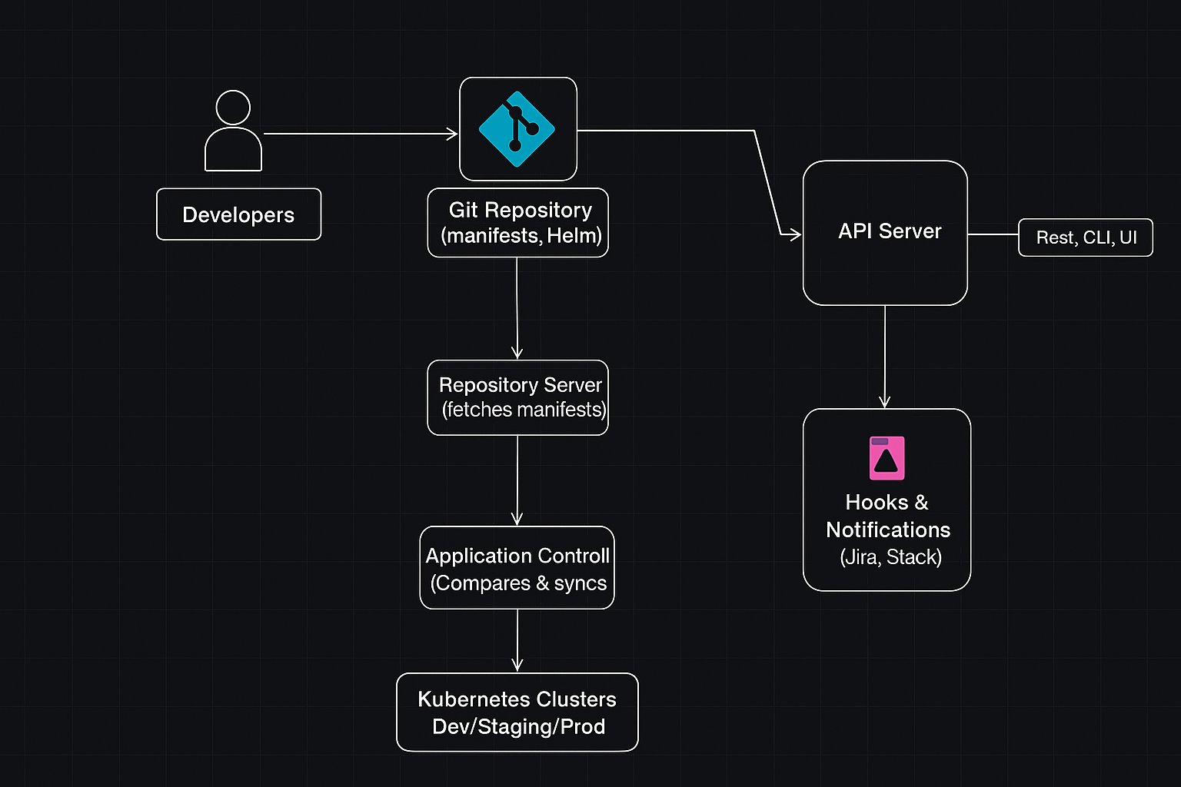

Developers push code to Git (manifests, Helm, Kustomize).  
**ArgoCD API Server** gives access via UI, CLI, or REST/gRPC.  
**Repository Server** connects to Git and fetches application manifests.  
**Application Controller** compares Git (desired state) with Kubernetes (live state).  
If there’s a difference, it syncs and deploys to the right cluster (dev, staging, prod, etc.).  
**Sync hooks and notifications** can trigger extra actions (like alerts in Slack).

**Example:**

Gmail syncs emails between the server (desired state) and your inbox (live state) using a sync engine and cache. ArgoCD syncs Git (desired state) and Kubernetes cluster (live state) using API Server, Repo Server, Application Controller, and Redis.